**CloudFormation - SNS - Assignment**

1. **Use the template from CloudFormation task 1.**

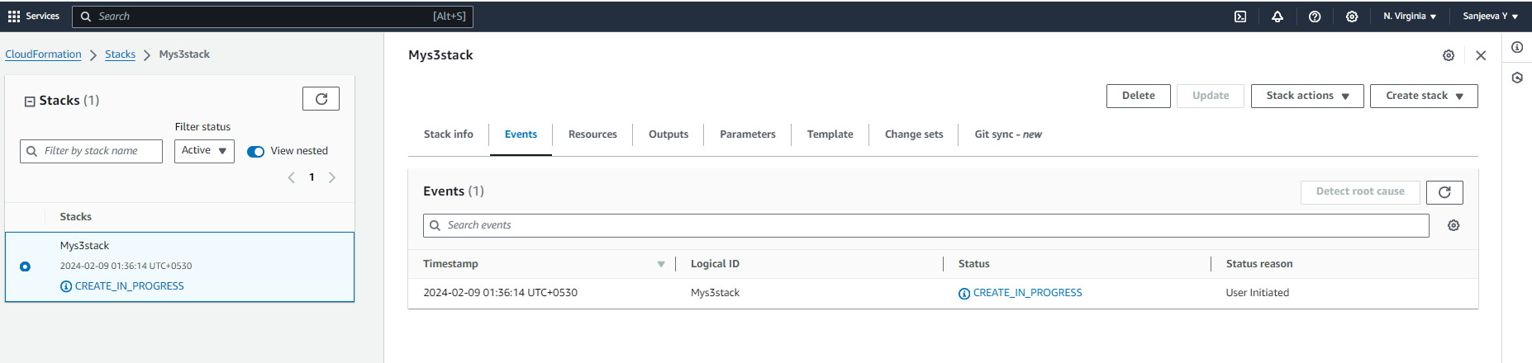

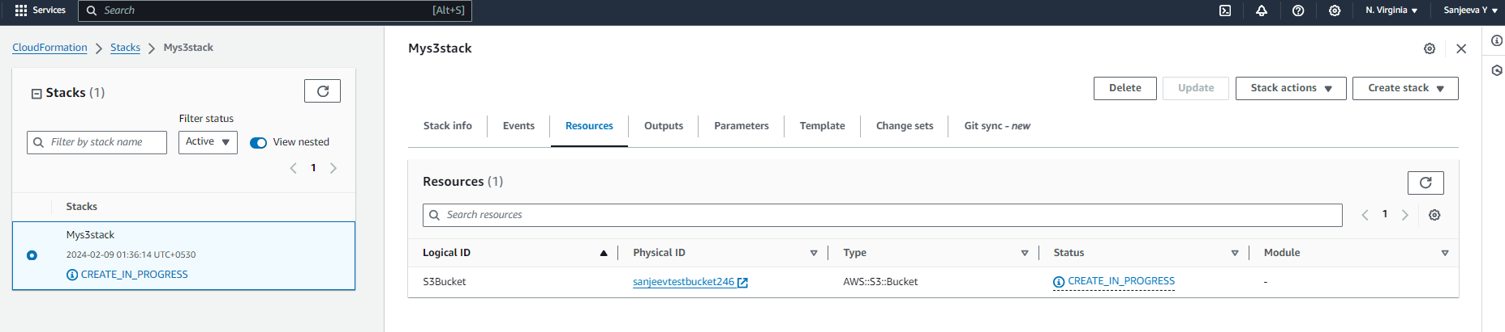

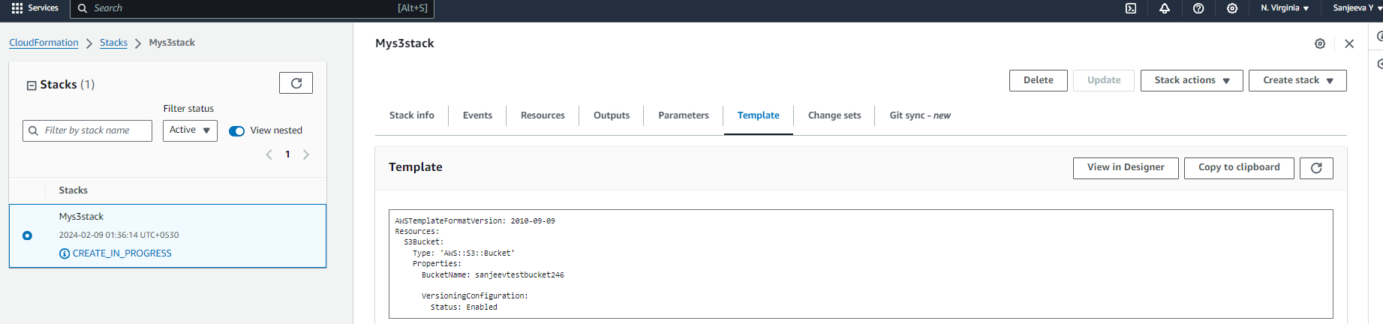

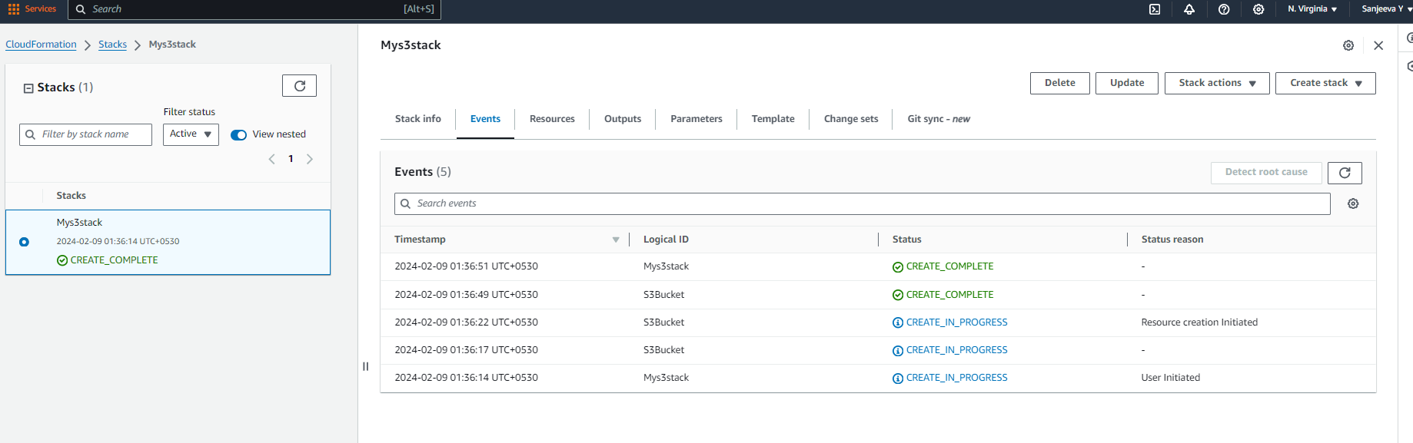

1. **Add Notification to the CloudFormation stack using SNS so that you get a notification via mail for every step of the stack creation process.**

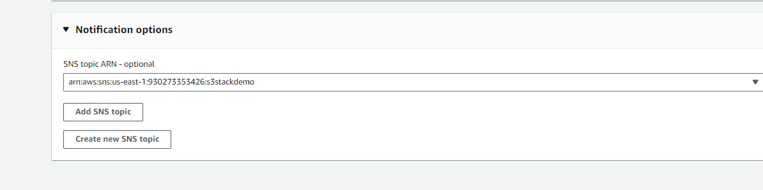

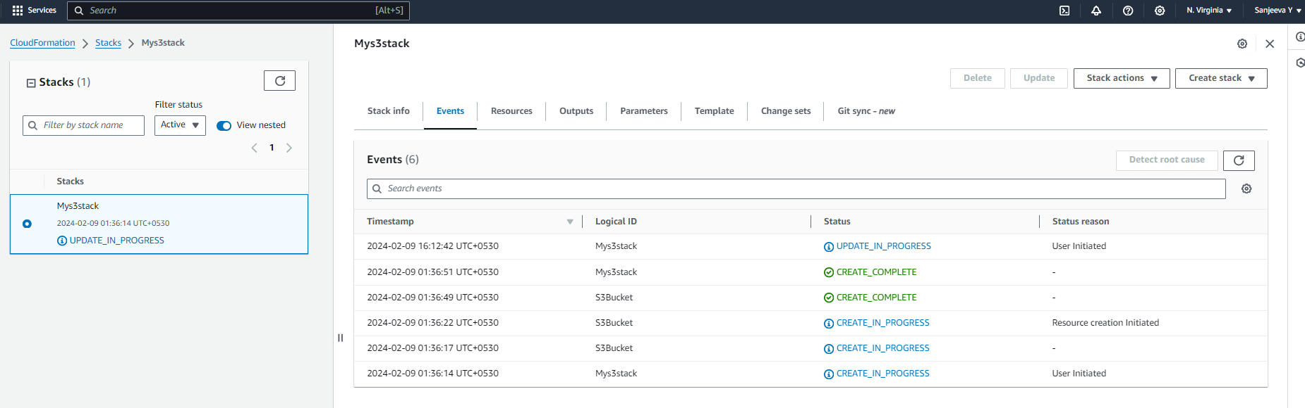

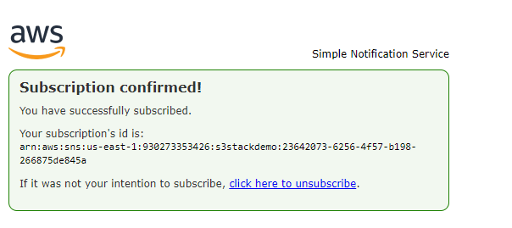

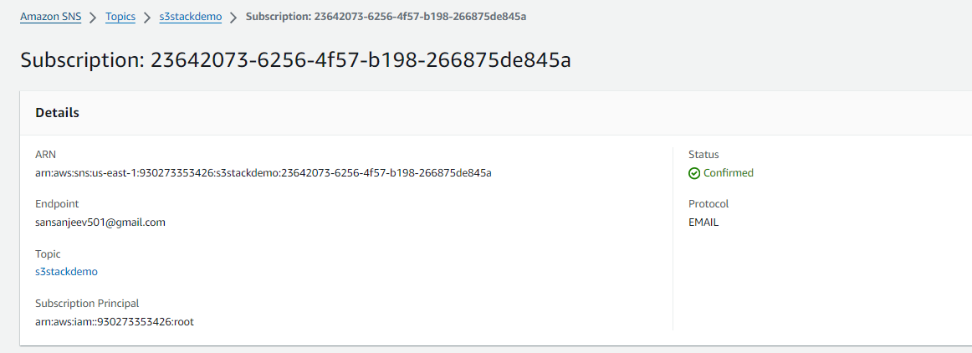

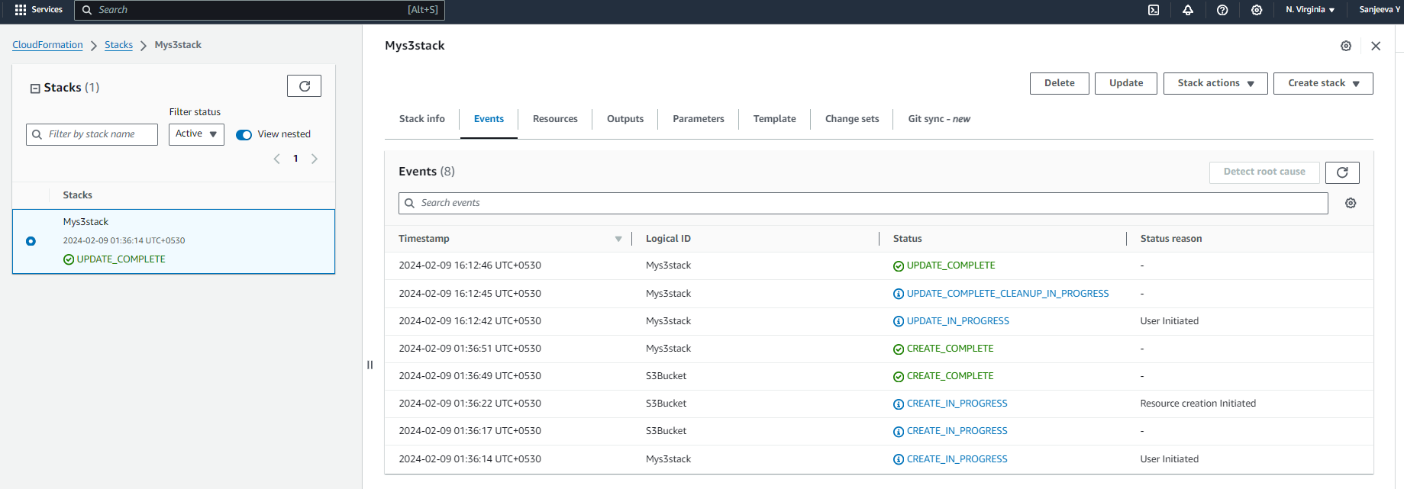

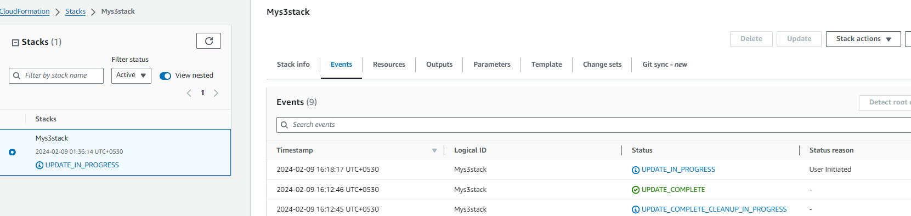

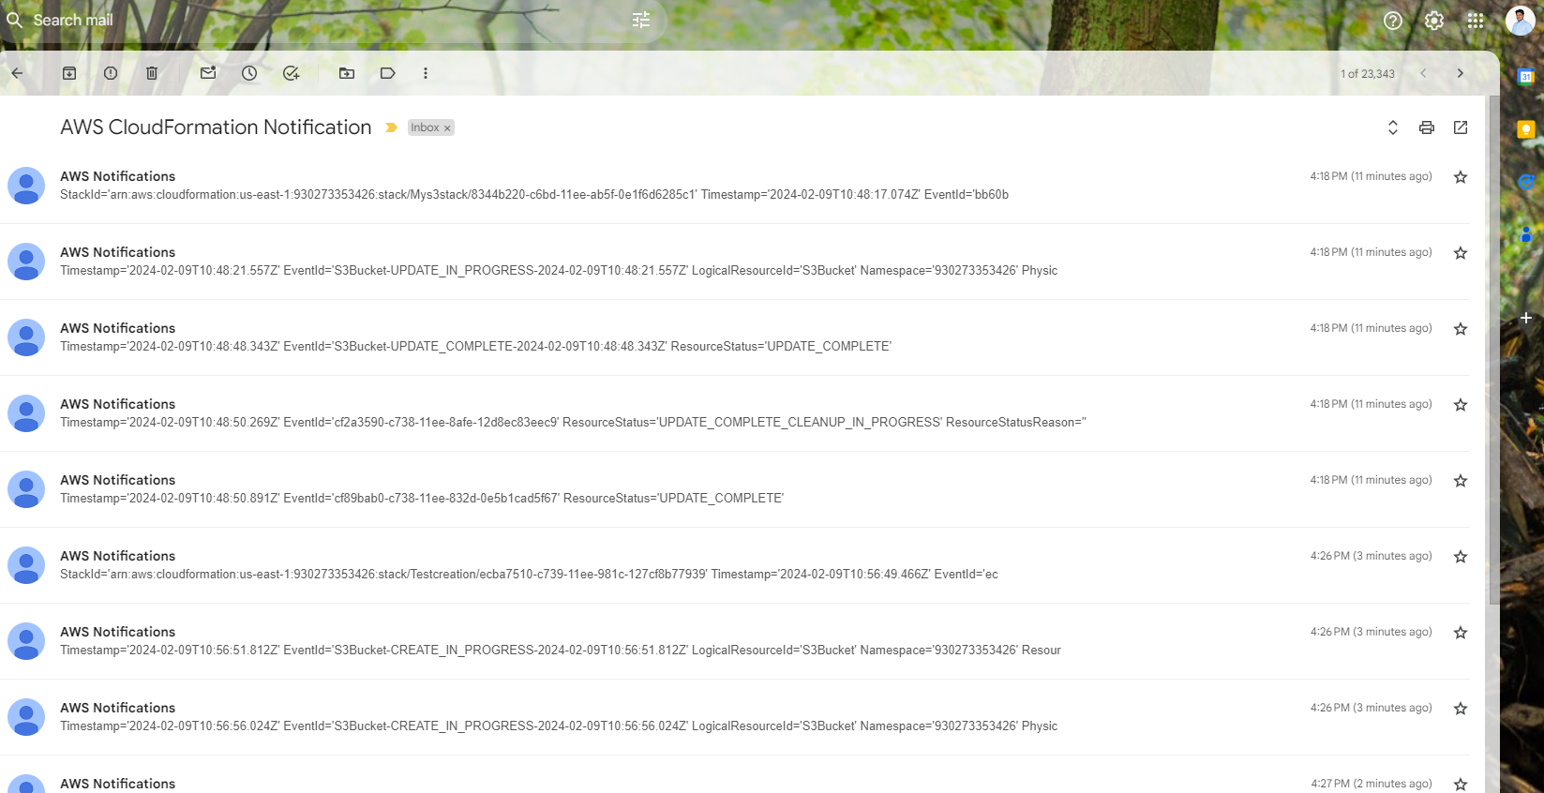

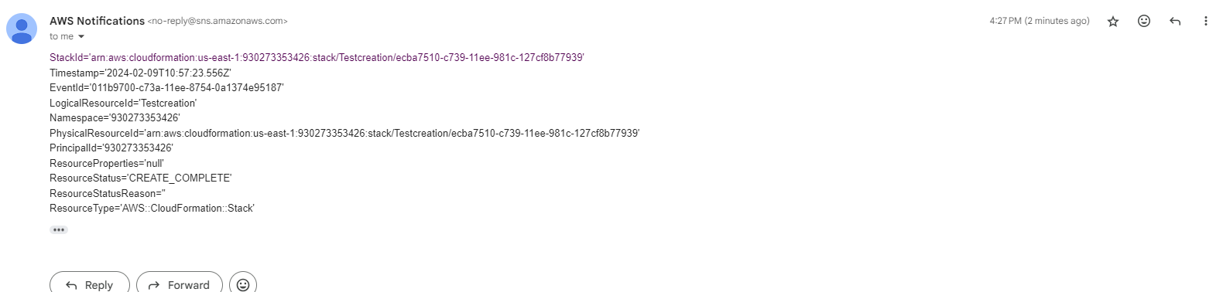

**CloudFormation - SQS & SES - Assignment**

1. **Create a FIFO SQS queue and test by sending messages.**

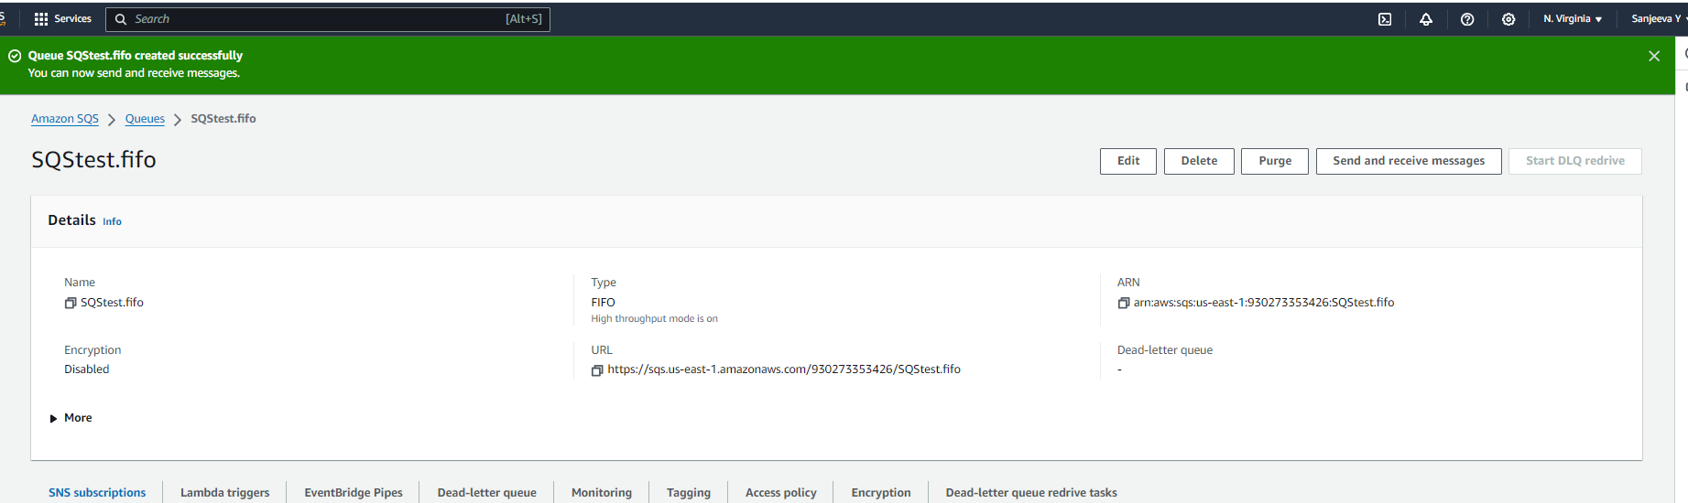

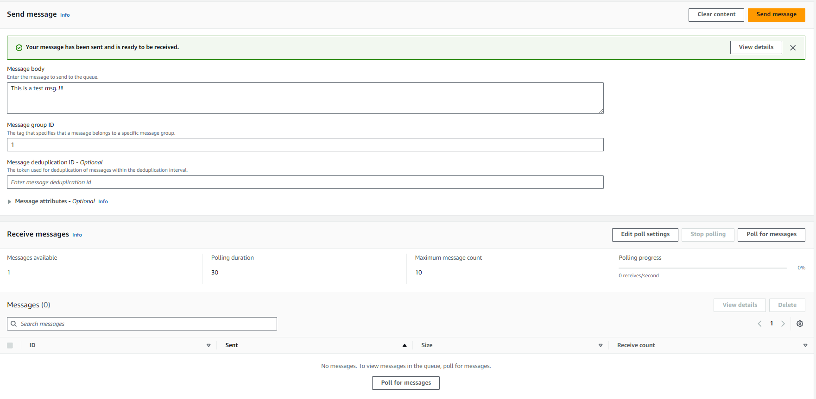 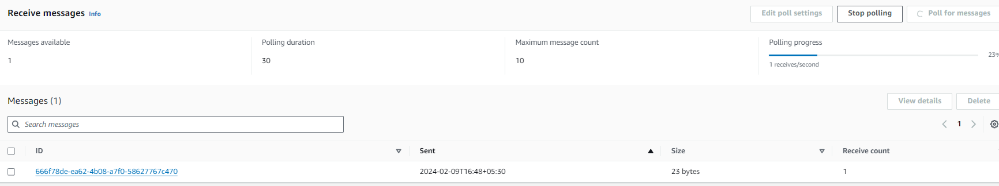 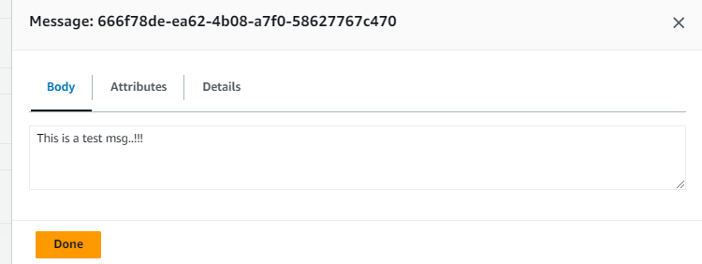

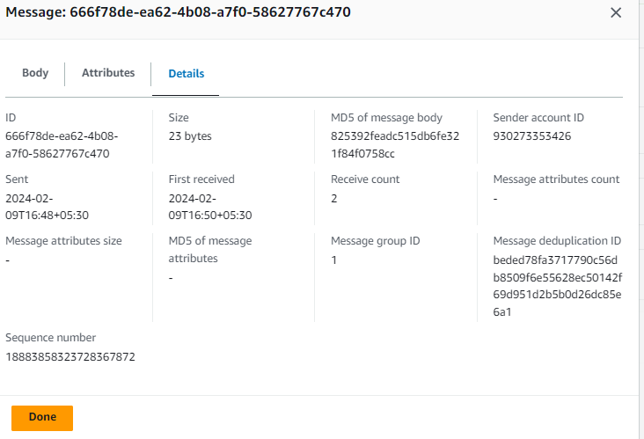

1. **Register your mail in SES and send a test mail to yourself.**

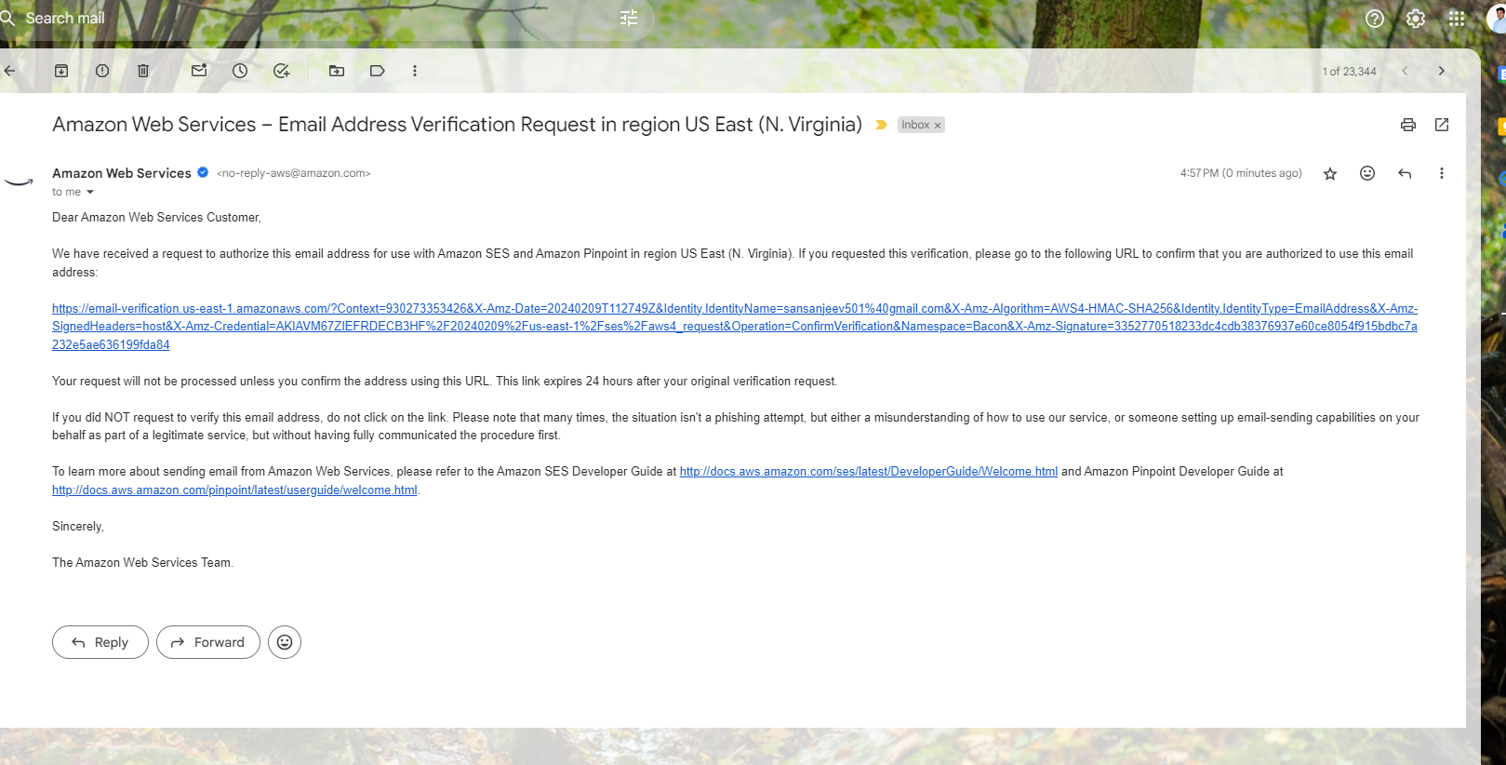

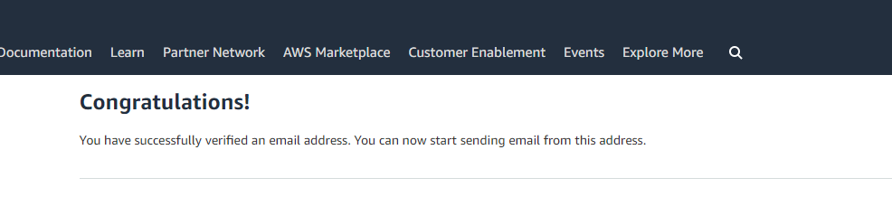

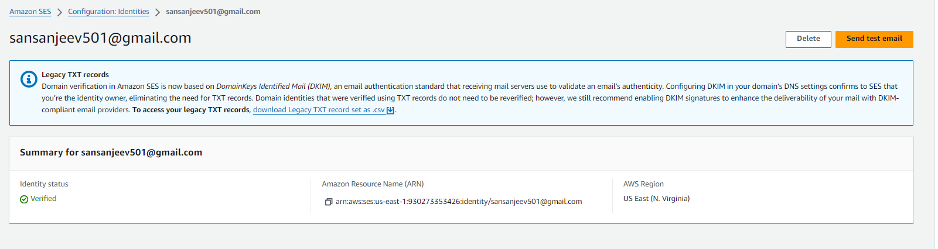

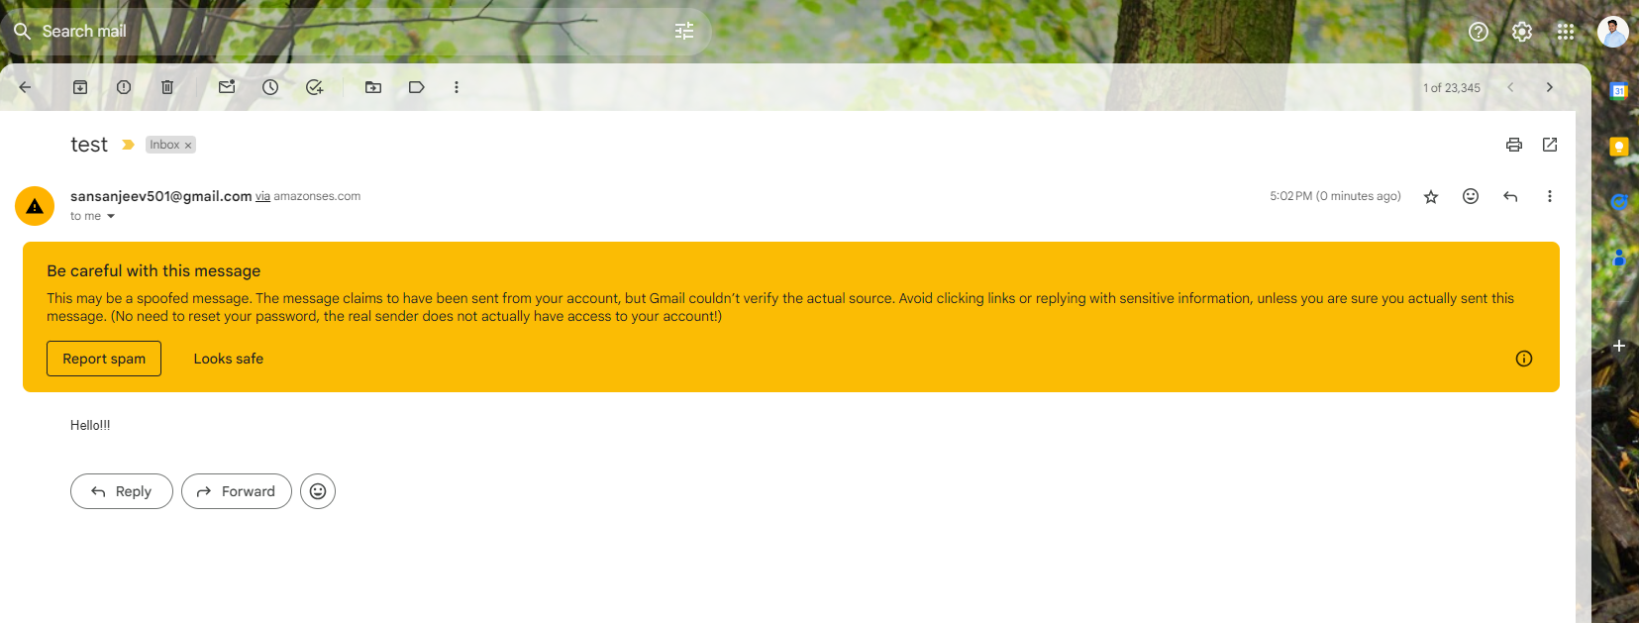

**Case Study – Multi-Tier Architecture**

**1. Web tier: Launch an instance in a public subnet and that instance should allow HTTP and SSH from the internet.**

**2. Application tier: Launch an instance in a private subnet of the web tier and it should allow only SSH from the public subnet of Web Tier-3.**

**3. DB tier: Launch an RDS MYSQL instance in a private subnet and it should allow connection on port 3306 only from the private subnet of Application Tier-4.**

**4. Setup a Route 53 hosted zone and direct traffic to the EC2 instance.**

**You have been also asked to propose a solution so that:**

**1. Development team can test their code without having to involve the system admins and can invest their time in testing the code rather than provisioning, configuring and updating the resources needed to test the code.**

**2. Make sure when the development team deletes the stack, RDS DB instances should not be deleted.**

